

24ADC001- BUSINESS INTELLIGENCE

--------------------------------------------------

2026-2027
LAB RECORD

DEPARTMENT OF ARTIFICIAL INTELLIGENCE AND DATA SCIENCE

INDEX
Expt. No | Title of the Experiment | Page No | Total Marks | Faculty Signature
1. | Explore the interface and basic features of the BI tool
2. | Load and visualize a sample dataset.
3. | Import a dataset into the BI tool. And Cleanse data by handling missing values, outliers, and  inconsistencies.
4. | Transform data to suit BI reporting requirements and Design a dashboard with  key performance indicators (KPIs).
5. | Develop interactive dashboards for dynamic data exploration.
6. | Integrate data from various sources for comprehensive analysis
7. | Implement advanced chart types (treemaps, heatmaps, etc.).
8. | Apply BI tools for forecasting and predictive analytics.

Average marks Faculty Signature

EXPT NO:1 | EXPLORE THE INTERFACE AND BASIC FEATURES OF BI Tool
DATE: 10.07.2026

PRE-LAB QUESTIONS (PROVIDE BRIEF ANSWERS TO THE FOLLOWING QUESTIONS)

- What is the purpose of Business Intelligence (BI) tools like Tableau and Power BI?
To connect to raw data, clean it, and transform it into interactive visual dashboards that help stakeholders make data-driven decisions quickly.

- List any three common data sources that Tableau and Power BI can connect to.
Excel/CSV files, SQL Databases (e.g., MySQL, PostgreSQL), and Cloud Data Warehouses (e.g., Snowflake, Google BigQuery).

- What is a dashboard in BI, and how is it different from a single chart?
A single chart displays one specific metric or relationship. A dashboard is an interactive, consolidated canvas containing multiple charts, KPIs, and filters to give a complete overview of a topic.

- Define the following terms:
  - Visualization - The graphical representation of information and data (e.g., charts, graphs, maps).

  - KPI - Key Performance Indicator; a quantifiable metric used to evaluate how successfully an objective is being met.

  - Data Filter - A condition applied to a dataset to include or exclude specific data points from a visualization.

- Why is it important to clean and transform data before visualization?
Visualizing dirty data (missing values, duplicates, outliers) leads to false trends and incorrect business decisions. Clean data ensures accuracy and reliability.

- What kind of chart would you use to analyze stock price trends over time?
A Line Chart is best for showing continuous data over a time series.

- Explain the role of slicers in Power BI and filters in Tableau.
Both restrict the data shown. Slicers are on-canvas, interactive visual controls designed for the end-user to easily click and filter. Filters are often configured in the background by the developer to restrict data at the visual, page, or report level.

- What does a calculated field or measure do in BI tools?
They allow you to create new data from existing data using mathematical formulas or logic functions (e.g., calculating a "Prediction Error" metric from existing predicted and actual price columns).

- What are the advantages of using interactive dashboards for financial data analysis?
They allow users to drill down into specific date ranges or specific stocks, uncover hidden patterns, and update dynamically as underlying data changes.

- Which function would you use to find the absolute difference between predicted and actual stock prices?

The ABS() function.

IN-LAB EXERCISE:
Objective:
To understand the basic interface, data import process, and fundamental visualization capabilities of Tableau and Power BI using a stock prediction dataset, and to explore their usefulness in analyzing financial data.

Tools Required:
- Tableau Public / Tableau Desktop
- Power BI Desktop
- Sample Dataset (CSV/Excel) containing:
Date, Stock Name, Open, Close, High, Low, Volume, Predicted Price

Exercise Steps:
Part 1: Working with Tableau
- Launch Tableau and connect to the stock prediction dataset.

Explore the Interface:
  - Understand components like Data Pane, Sheets, Marks Card, and Dashboards.

Create Basic Visualizations:
  - Line Chart: Show Close Price over time.
  - Scatter Plot: Plot Volume vs. Predicted Price.
  - Highlight Table: Display Predicted Price by stock.

Apply Filters:
  - Add filters for Stock Name and Date Range.

Create Calculated Field:
  - Calculate prediction error as |Predicted - Close|.

Design a Basic Dashboard:
  - Combine your charts into one interactive dashboard.

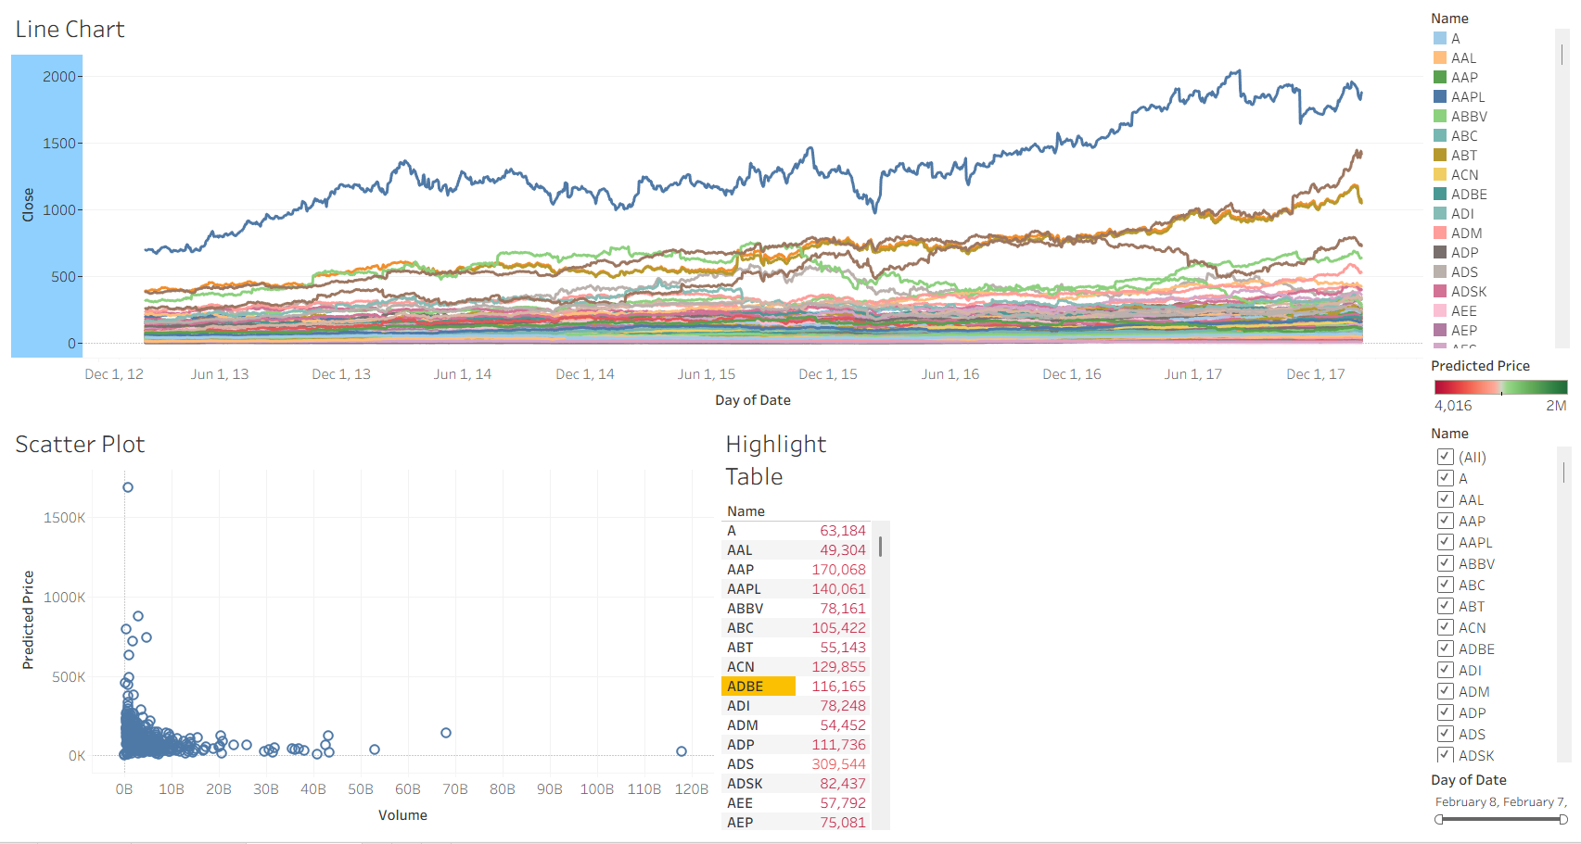

Part 2: Working with Power BI
- Open Power BI Desktop and import the same dataset.

Explore the Interface:
  - Familiarize with Fields Pane, Visualizations Pane, Report View, Data View.

Create Basic Visualizations:
  - Line Chart: Trend of Close Price over time.
  - Bar Chart: Compare Predicted Price vs. Close Price.
  - Card (KPI): Display average prediction error.

Use Filters and Slicers:
  - Filter data based on Stock Name and Date.
- Create a Simple Measure using DAX:
  - Example: Prediction Error = ABS(Predicted - Close)

Build a Report Page:
  - Arrange visuals in a single interactive page

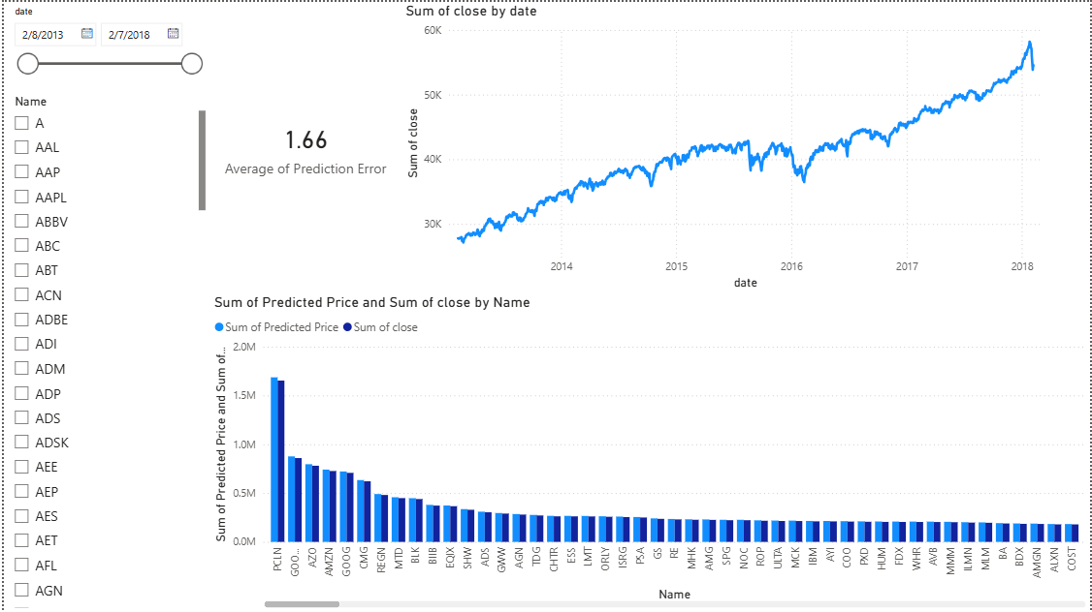.

POST-LAB QUESTIONS (PROVIDE BRIEF ANSWERS TO THE FOLLOWING QUESTIONS)
- Describe your experience with the Tableau interface. What components did you interact with?
The interface is highly segmented. I interacted primarily with the Data Pane to load measures and dimensions, the Marks Card to adjust color and details, the Columns and Rows shelves to build the individual charts, and the Dashboard canvas to assemble the final view.

- How did you import the dataset into Tableau and Power BI?
In Tableau, I connected to the CSV directly from the start screen before moving to the worksheet. In Power BI, I used the "Get data" -> "Text/CSV" option on the Home ribbon to load the table into the Data pane.

- What types of visualizations did you create in both tools? List at least two per tool.
In Tableau, I created a Line Chart and a Scatter Plot. In Power BI, I created a Clustered Column Chart (Bar Chart) and a Line Chart.

- How did you calculate the prediction error, and how was it displayed in your dashboard?
In Tableau, I created a Calculated Field. In Power BI, I created a new column using a DAX formula: ABS('all_stocks_5yr'[Predicted Price] - 'all_stocks_5yr'[close]). It was displayed as a KPI Card showing the average error.

- Which filtering or slicing techniques did you apply, and what insights did they reveal?
I applied Date range sliders and Stock Name checklists. This allowed for isolating specific stock trends over custom timeframes, revealing that prediction accuracy varied significantly depending on the specific stock and market volatility during that period.

- Compare the process of creating a line chart in Tableau vs. Power BI. What differences did you notice?
Tableau required dragging dimension and measure pills to the Columns (Date) and Rows (Close) shelves on a dedicated worksheet. Power BI allowed selecting the Line Chart visual directly on the main canvas and dragging fields into the X-axis and Y-axis parameter boxes.

- How did you organize the dashboard in Tableau and Power BI? What key elements did you include?
I organized the layouts with a dedicated control panel for slicers/filters on the left, a prominent KPI card near the top, and the primary visualizations (Line and Bar/Scatter charts) taking up the majority of the canvas aligned to a grid.

- Which tool (Tableau or Power BI) did you find more user-friendly for financial data visualization, and why?
Power BI felt more user-friendly for rapid dashboard assembly because all visuals and slicers are built on a single unified canvas from the start. Tableau required building individual sheets and manually configuring filters to apply across all components on the final dashboard.

- What challenges did you face while creating visualizations or dashboards?
A main challenge was ensuring that filters in Tableau correctly communicated with all worksheets on the dashboard, which required explicitly setting the filter to apply to "All Using This Data Source."

- How can the knowledge gained from this lab be applied to real-world financial data analysis?
These skills can be used to build automated financial reporting tools, monitor portfolio performance in real-time, and visually backtest predictive models against historical market data to identify trends and trading opportunities.

ASSESSMENT

Description | Max Marks | Marks  Awarded
Pre Lab Exercise | 5
In Lab Exercise | 10
Post Lab Exercise | 5
Viva | 10
Total | 30
Faculty Signature

